Developing a web application to improve communication in the industry.

**E. Dreyer**

Research methodology for the Dissertation submitted in partial fulfillment of the requirements for the degree *Bsc in Information Technology Hons* at the Vaal Campus of the North-West University

Supervisor: Dr. Suné Van Der Linde

Co-supervisor: Mr. Luke Coetzee

Date of submission: 2021/05/12

Version: 1.0

Table of Contents

LIST OF ABBREVIATIONS iii

Chapter 2: Research Methodology 1

1. Project description 1

2. Problem description and background 1

3. Aims and objectives of project 1

4. Literature review 2

A. Introduction 2

B. Paradigms 2

1.1.1 The interpretivism paradigm 3

1.1.2 Design science paradigm 4

1.1.3 positivism paradigm 4

C. Positioning and motivation of the chosen paradigm 4

D. Research methodology literature 5

1.1.1 Conclusion 7

E. Reflection and Integration 7

1.1.1 Design science research process model 8

1.1.2 Agile Methodology 10

1.1.3 Research Objectives According to the Process Model 12

1.1.4 Data gathering techniques 13

1.1.5 Conclusion 14

1.1.6 Ethical consideration in qualitative research 14

5. Conclusion 15

BIBLIOGRAPHY 16

LIST OF ABBREVIATIONS

EU European Union (Abbreviation)

List of Figures

Figure 1: Peffers Design Science Research Proccess Model 6

Figure 2: Vijay Vaishnavi Design Science Research Process Model 8

Figure 3: Agile Methodology (Roman, 2018) 10

List of Tables

Table 1: Philosophical Assumption of Interpretive, Design and Positivist 3

Chapter 2: Research Methodology

# Project description

The goal of this study is to develop a web application that can be used to enhance communication between developers and management at a South African software development company. To reach the goal of this study, research on the different research methodologies has to be done.

According to Cambridge University (2015), research is a detailed study of a subject, but more specifically to reach a new understanding or to discover new information. This is described as a number of overlapping or similar activities that involve the search of information.

In this chapter, the different paradigms will firstly be discussed, followed by positioning and motivation of the chosen paradigm for this study. The research methodology that was chosen is then discussed in-depth, as well as the qualitative data gathering techniques, and ethical considerations that need to be kept in mind.

# Problem description and background

In the corporate world, businesses rely on effective communication to succeed. As developers, we lack the number of screens that we need to keep all our important tabs open. This makes it harder for important messages to reach developers and influences productivity and creativity (Schrader, 2018).

As a solution, an artifact has to be developed to assist with the effectiveness of communication in the industry.

# Aims and objectives of project

This study proposes the development of a communication web application that can easily be viewed in an office by all employees to allow easy access to important communication regarding specific software development projects. Where the primary objective is to develop a web application for a South African software development company that allows for easy access to important communication relating to specific project.

# Literature review

## Introduction

A research methodology is defined as the specific techniques or procedures that can be used to select, identify, analyse and process information or data on a specific topic (Duke & Mallette, 2011). The methodology section in a research paper, allows a reader to assess the overall reliability and validity of a study.

This section revolves around a couple of questions: How was the data analysed? And how was the information and data generated or collected. The literature review for this study includes research on what is functionality in needed in the artefact.

## Paradigms

According to Sahifa (2017) a research paradigm can be defined as a research model or approach used to conduct research. This model or approach has to be verified by the research community as well as be in practice for hundreds of years to be considered a paradigm.

The three paradigms that are most common are interpretivism, design science and positivism (Vijay Vaishnavi, 2004). The research paradigms will be discussed in short in the section below.

Each paradigm can be broken up into four philosophical assumptions named Ontology, Epistemology, Methodology, and axiology (McGregor & Murnane, 2010). Ontology focuses on the reality and strives to understand the social world, just like the natural world. Epistemology focuses on objects and strives to study a situation or fact that exists or happened, without disturbing or affecting that phenomena (Vosloo, 2014). Methodology focuses on the methods and how it is used to capture data. Axiology focuses on the values that are relevant to the study and what those values hold and why. (Vijay Vaishnavi, 2004).

The following table shows the philosophical assumption of the three research perspectives according to Vijay Vaishnavi (2004).

Table 1: Philosophical Assumption of Interpretive, Design and Positivist

|  |  |  |  |
| --- | --- | --- | --- |
| Basic Belief | Research Perspective | | |
| Interpretive | Design | Positivist |
| Ontology | Socially constructed and Multiple realities. | Socio-technologically enabled. Contextually situated, Multiple alternative world-states. | A single reality, probabilistic, knowable. |
| Epistemology | Subjective that is knowledge and values emerge from the researcher-participant interaction. | Knowing through constructing. Objectively constrained construction within a context. Iterative circumscription reveals meaning. | Objective. Detached observer of truth. Dispassionate. |
| Methodology | Participation. qualitative, dialectical, and hermeneutical. | Developmental. Measure artefactual impacts on the composite system. | Observation. statistical, quantitative. |
| Axiology | Understanding. Description and situated. | Creation, Control, Progress(improvement), and understanding. | Truth. beautiful and universal. Prediction. |

### The interpretivism paradigm

The interpretivism paradigm is there to understand and research the subjective world of human experience and emphasises the understanding of individuals and the interpretation of the world around them (Dean, 2018). Through a consistent manner, grounding theory is used to analyse and gather data, and researchers try to discover patterns in the data collected to understand a generated theory or phenomenon (Strauss & Corbin, 1990).

### Design science paradigm

Design science as a paradigm is based on two major activities that are design, and investigation of the artifact (Wieringa, 2014). The design of the artefact is intended to interact with someone or something to solve a certain problem. Evaluation methods in design science are to develop prototypes of the artifact, interviews and field experiments (Ken Peffers, 2008).

### Positivism paradigm

The positivism paradigm is based on the theory that to maximise the understanding of humanity is trough reason and observation (Ntgrty, 2016). According to this paradigm, the assumption is made that reality is independent from humanity. It focuses on getting facts through empirical qualitative analysis and methods and is based on solving everyday problems with the use of analysing statistics (Vosloo, 2014).

## Positioning and motivation of the chosen paradigm

As the primary objective of this study is to develop a web application to improve communication in the industry, design science research was chosen to be the most applicable paradigm for this study. Researchers using design science use and artifact to solve a certain problem (Peffers, 2008), thus designing and investigating a web application will solve the main problem of this study.

A web application serves as a way of getting information easily and is accessible on any computer device that has an internet connection. This will further increase the effectiveness of the artifact and achieve the objectives of this study.

Design science research was the most suitable paradigm and will be discussed in the next section of the paper.

## Research methodology literature

According to Pello (2018) design science research is a new approach to research to reach a goal of creating a new reality, instead of making sense of an existing reality. Whereas Vijay Vaishnavi (2004) defines design science research as a set or “lens” of analytical and synthetic perspectives and techniques for conducting research in Information Systems.

Design science research usually involves the development of a design theory or an artifact as well as finding a way to improve the current state of the way that it is being used, as well as researching existing knowledge (Ken Peffers, 2008).

Design science primarily focuses on two activities that can be used to understand the behaviour of certain aspects and improvement of Information Systems. These two activities that are focused on are: (1) the making of new knowledge with the use of the development of innovative artefacts and (2) analysing the artefacts for its usefulness and performance with abstraction and reflection (Vijay Vaishnavi, 2004). Some artifacts in the process of design science include computer interfaces, algorithms, or system design methodologies.

The word design, as defined by Vijay Vaishnavi (2004), is to invent something and bring it into being. Thus, design science has the intention to create something new that does not exist. If there is already a design out there with the same intentions as the one being developed then the design is seen as *routine*, if it does not exist outside of the research, then it is seen as *innovative.*

This study is seen as routine, because there are existing knowledge for creating the artifact and there is no need for conducting research to fill the gap where there is a lack of knowledge (Vijay Vaishnavi, 2004).

Different Design Science research can follow different approaches and processes. An example is the use of either the Process Model developed by Peffers et al. (2006) or the Process Model developed by Vijay Vaishnavi (2004) to help with the guidance of doing Design Science Research. To decide what Process Model is the most applicable to this study, research has to be done on both.

Following is the process model developed by Peffers et al. (2006).

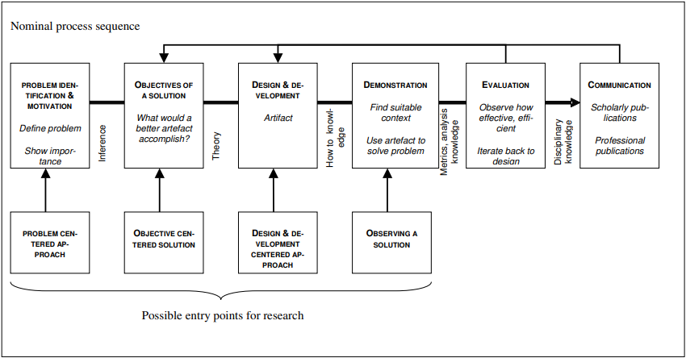

Figure 1: Peffers Design Science Research Proccess Model

This process model consists of six steps and will be discussed shortly in the following section of the paper.

1. Problem identification and motivation

This is the recognition that there is a need for this process model in Information Systems and that there is a need for design science research to be done on this topic.

1. Objectives of a solution

This is the development of the objectives that is needed to be reached in the research, as well as a mental model for the Design Science Research output.

1. Design and Development

This is where an artifact solution is created. This includes the activity of determining the functionality that the artifact must have.

1. Demonstration

This is where the researcher has to demonstrate how the artifact can solve the given problem. This includes experimentation, case studies, simulations, or any other activity to show its effectiveness.

1. Evaluation

This is the measurement on how well the artifact can solve the given problem. This is comparing the objectives given in the objectives of a solution phase to the functionality of the artifact.

1. Communication

This is the communication of the problem, how important the artifact is, and how effectively it can solve the problem.

### *Conclusion*

There is no right or wrong Process model to follow and after researching both the Process Model developed by Vijay Vaishnavi (2004) and the Process Model developed by Peffers et al. (2006), the Vijay Vaishnavi (2004) Process Model was chosen because of the easier flow of phases and more time spent on the development phase. Due to the size of the research, there was no need for the additional phases that the Peffers et al. (2006) Process Model had to offer. Due to more time in the Development phase, the Vijay Vaishnavi (2004) Process Model also allowed the use of an Agile methodology in the Development phase, thus improving the quality and outcome of the artifact.

Following is the an in-depth discussion on the Vijay Vaishnavi (2004) Process model as the chosen Design Science Process Model.

## Reflection and Integration

In this section of the paper, the focus will be on design science research methodology that is used to achieve the aims and objectives of this study through the creation of an artifact.

### Design science research process model

In this section, a model of the overall process that is followed by design science will be discussed as described by Vijay Vaishnavi (2004). The Vaishnavi model is based on the process model developed by Takeda et al. (1990). Although there are similarities in the design process, activities in the different phases are not the same. The Vaishnavi process model also focuses more on the contribution of new knowledge.

Following is the Vijay Vaishnavi (2004) Process Model.

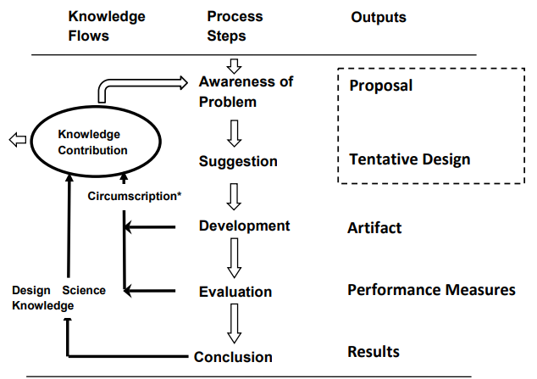

Figure 2: Vijay Vaishnavi Design Science Research Process Model

This process model consists of five steps and will be discussed shortly in the following section of the paper.

1. Awareness of problem

According to Vijay Vaishnavi (2004), this phase can come from different sources and include identification of problems or new developments in the industry. Reading different articles on this field opens up the opportunity for new findings in other fields. Typically, the questions in this phase are focused on finding an approach to solve the problem, and not questions that can be answered through explanation.

Part of this phase is to become familiar with ways in which the final artifact can be evaluated to see if it had solved all of the objectives. The output of this phase is an informal or formal proposal for a new attempt on research.

In this study, the problem is the improving the communication between project managers and project developers, by having an easy way to access to important communication related information.

1. Suggestion

After the Awareness of problem phase is the suggestion phase. This phase revolves around creativity and new functionality based on the novel configurations from either existing or new elements. As part of the integral proposal, a Tentative Design and performance of that design is needed.

When the researcher is not happy with the with the Tentative Design and considerable effort was put into it, the Proposal will be set aside. Thus, there are dotted lines over the Proposal and Tentative Design (as shown in Figure 1) for the connection between the Awareness of Problem phase and Suggestion phase.

In this study, an interview will be held with an experienced project manager from industry. The Tentative Design will be made according to the project manager suggestions. This will form part of the requirement analysis.

1. Development

In this phase the Tentative Design is developed and implemented further. There are various ways to develop an artifact, from design theories (Lindner & Rodger, 2017) to instantiations, models, concepts or processes (Laurillard, 2013). The techniques will vary from one artifact to another. In some cases, a formal proof may need to be constructed to show correctness. For this study, a model will be made to achieve its objectives and get the desired outcome.

### Agile Methodology

In the development phase, an Agile methodology will be followed to break the development phase into smaller pieces.

Agile was designed to overcome the old waterfall way of programming, by using the agile methodology, the prevention is made from having to start the whole project from the start because of something that happened in the Awareness of Problem phase (Kumar & Bhatia, 2012).

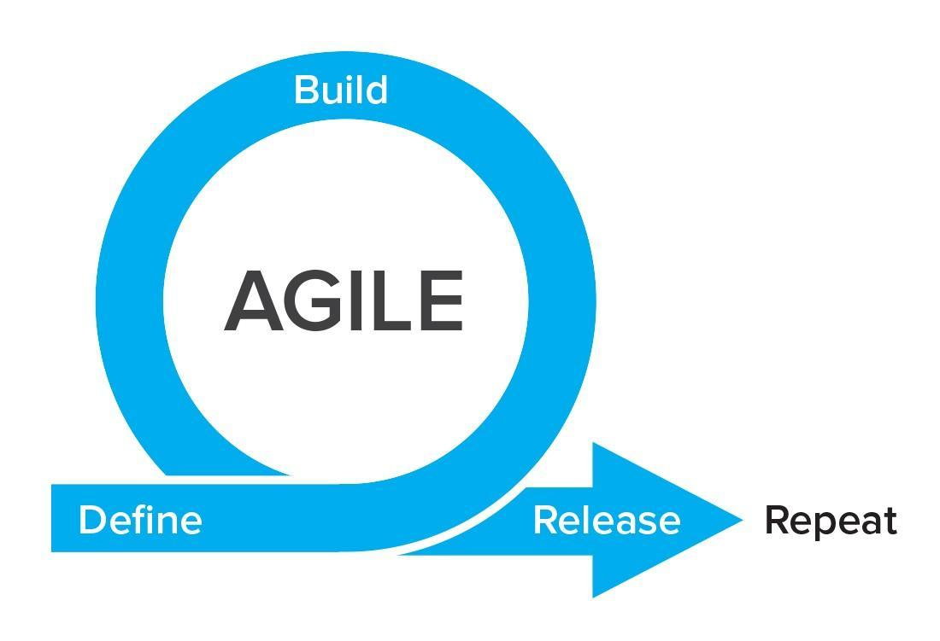

Figure 3: Agile Methodology (Roman, 2018)

In this Methodology the idea is to create smaller phases of the project called sprints. A sprint is a short period of time that is allocated for a small part of the project that helps focus only on the most important work that needs to be done. As shown in Figure 2, you break every feature into three phases namely: Define, Build, and Release.

**Define** is where you take one feature that comes from the backlog of the project. A backlog is a list of features that still needs to be done. Unless told otherwise, the highest priority that will satisfy the customer will be picked to be done first (Roman, 2018).

**Build** is where you spend time on building the new feature. This usually takes the most time and can also be broken down into steps. If the build is not successful, the developers need to come back to the phase to fix the bugs or change the whole feature.

**Release** is where you release the final feature into the live environment. Feedback is needed from the customer on a daily basis, to ensure that the project is on track and that the feature is what they wanted.

For this study, a web application will be designed according to the requirements given by the interview done in the Suggestion phase.

1. Evaluation

Once the development phase is complete, the artefact is evaluated according to the criteria that was make in the Awareness of Problem phase. In positivist research this is where the evaluation will result in either a contradiction or confirmation of the hypothesis by in design science research the results of the evaluation can be used to gain information and be used to improve the artifact (Vijay Vaishnavi, 2004).

Design science focuses on the utility of the artifact (Alan Hevner, 2004), but in this study it should also be considered to be evaluated for its fitness to survive and adapt within the industry environment as suggested by T. GRANDON GILL (2013).

The results of the evaluation will either suggest a redesign of the artifact, therefor additional research is needed on why this artifact was not successful or move on the conclusion phase of the process model.

In this study, the web application will be evaluated by the suggestions made by the project manager that was interviewed in the suggestion phase. The feedback will be used to improve the artifact.

1. Conclusion

This is the last step in the process model and the result is typically satisfaction of the artifact. This phase does not only revolve around the artifact but also the experience and knowledge that the researcher has gained. As part of the conclusion phase there is an arrow pointing out of the knowledge contribution as shown in Figure 1, that means that the artifact is going to contribute to the research area and is seen as complete.

In this study the artifact will contribute to the research area if it meets the requirements that was made in the suggestion phase as well as survive and adapt to the industry.

### Research Objectives According to the Process Model

An objective is defined as something that you plan on doing or to achieve (Insights, 2019). Each Phase in the Process model has its own objectives. Following will be each phase along with its specified objectives.

1. Awareness of problem

* Gain knowledge of Design Science Research.
* Get a basic idea on what is expected of the artifact.

1. Suggestion

* Conduct an interview with a project manager that has experience in the industry.
* Use the information gathered to improve the design of the artifact.

1. Development

* Develop the web application according to the information gathered by the interview.
* Break the project up into small processes and divide into sprints.

1. Evaluation

* Evaluate the web application with the given requirements from the suggestion phase.
* Assure that the developed artifact can survive and adapt with the industry environment.

1. Conclusion

* Report whether the artifact has achieved its main objective and that is to enhance communication between project managers and project developers in the industry.

### Data gathering techniques

According to Lochrie et al. (2015), qualitative gathering techniques can yield revelatory, rich, and valuable data. As an example, a qualitative interview involves a conversation between a subject and the researcher that results in the understanding towards central themes such as accessibility to a certain feature.

Methods that can be used for qualitative data collection are:

1. Individual interviews

This is the most widely used and trusted qualitative data collection method. This is the direct conversation between a researcher and a subject. The questions are designed to get the subjects knowledge or perspective on a certain topic, issue, or program.

1. Qualitative surveys

This is used for more open-ended questions where the responded has to write their own opinions on a topic or issue. This can be done wither by giving out papers or online. Where the online surveys give a wider variety of people, for if the researcher wants to gather information around the world.

1. Focus group discussions

A focus group discussion can be seen as a type of interview, but instead of having one individual, it is conducted with a group of people. The use of this is to see how people feel as a group, where a range of responses are available and discussed.

1. Observations

This allows researchers to gather descriptive data by observing a subject and seeing its behaviour in a natural way. Observation only allows the researcher to be completely immersive and not participating in the activity and is only there to take notes. There are different ways to observe, such as taking videos or pictures.

### Conclusion

The qualitative data gathering technique that will be used in this study is interviews, as it is considered to be the most applicable to get the most valuable data that is needed. The questions will focus gathering important features for the web application as well as getting input on the user interface design.

### Ethical consideration in qualitative research

According to Roller (2015), there are certain ethical considerations to keep in mind when conducting an interview for this study.

* Voluntary consent from the participant.
* Give participants the option to stay anonymous.
* That the participant is allowed to give their own opinion at all times.
* Only interview a participant that is relevant to the study.

Along with the mentioned ethical considerations, a study leader and the ethics committee of NWU (North-West- University) has to approve the qualitative research done by this study.

# Conclusion

The goal of this study is to develop a web application that can be used to enhance communication between developers and management at a South African software development company. In the corporate world, businesses rely on effective communication to succeed and plays a big role in day-to-day activities in the industry.

This study proposes the development of a communication web application that can easily be viewed in an office by all employees to allow easy access to important communication regarding specific software development projects

According to Vijay Vaishnavi (2004) there three paradigms that are most common are interpretivism, design science and positivism and each one of them have their own part in the research world, with all of the having different outcomes.

In design science there are different approaches and processes that can be followed. This paper discussed two process models namely: the Peffers et al. (2006) Process Model and the Vijay Vaishnavi (2004) Process model. Mainly due to the size of the research the Vijay Vaishnavi (2004) Process Model was chosen due to it being the easier Process model to follow and still be able to apply an Agile methodology in the Development phase.

Each phase in the Process Model has its own objectives and was discussed. The four qualitative data gathering techniques are individual interviews, qualitative surveys, focus group discussions and observation. Interviews was the technique that was the most applicable to this study and ethical considerations were discussed.

BIBLIOGRAPHY

Alan Hevner, S. M., Jinsoo Park, Sudha Ram. (2004). Design Science Research in Information Systems. <http://www3.cis.gsu.edu/vvaishnavi/9220Sp07/Documents/Hevner%20et%20al.%202004%20MISQ.pdf>

Dean, B. A. (2018). THE INTERPRETIVIST AND THE LEARNER. <http://ijds.org/Volume13/IJDSv13p001-008Dean3944.pdf>

Dovleac, L. (2015). The role of new communication technologies in companies' sustainability. *Bulletin of the Transilvania University of Brasov. Economic Sciences. Series V*, *8*(1), 33.

Duke, N. K., & Mallette, M. H. (2011). *Literacy research methodologies*. Guilford Press.

Insights, E. (2019). What are research objectives? <https://www.editage.com/insights/what-is-research-objective>

Ken Peffers, M. R., Tuure Tuunanen and Reza Vaezi. (2008). Design Science Research Evaluation. <http://www.sirel.fi/ttt/Downloads/Peffers%20et%20al%20DSR%20Evaluation.pdf>

Kumar, G., & Bhatia, P. K. (2012). Impact of agile methodology on software development process. *International Journal of Computer Technology and Electronics Engineering (IJCTEE)*, *2*(4), 46-50.

Laurillard, D. (2013). *Teaching as a design science: Building pedagogical patterns for learning and technology*. Routledge.

Lindner, C. C., & Rodger, C. A. (2017). *Design theory*. CRC press.

Lochrie, S., Curran, R., & O’Gorman, K. (2015). Qualitative data gathering techniques. *Research Methods for Business and Management*.

McGregor, S. L., & Murnane, J. A. (2010). Paradigm, methodology and method: Intellectual integrity in consumer scholarship. *International journal of consumer studies*, *34*(4), 419-427.

Ntgrty. (2016). *The research paradigms: Positivism*. <https://www.intgrty.co.za/2016/07/19/the-research-paradigms-positivism/#:~:text=The%20positivist%20paradigm%20of%20exploring,be%20the%20basis%20for%20science>.

Peffers, K., Tuunanen, T., Gengler, C. E., Rossi, M., Hui, W., Virtanen, V., & Bragge, J. (2006). THE DESIGN SCIENCE RESEARCH PROCESS: AModel FOR PRODUCING AND PRESENTING INFORMATION SYSTEMS RESEARCH. First International Conference on Design Science Research in Information Systems and Technology,

Peffers, K. a. T., Tuure and Rothenberger, Marcus A. and Chatterjee, Samir. (2008). Peffers et al. (2008) A Design Science Research Methodology for Information Systems Research. <http://www.umfundi.barbourians.org/article/peffers2008design>

Pello, R. (2018). Design science research — a short summary. <https://medium.com/@pello/design-science-research-a-summary-bb538a40f669>

Roller, L. (2015). *ETHICAL CONSIDERATIONS IN CASE-CENTERED QUALITATIVE RESEARCH*. <https://researchdesignreview.com/2016/06/16/ethical-considerations-in-case-centered-qualitative-research/>

Roman, V. (2018). Agile Methodology: Revolutionizing Project Management. <https://rromanss23.medium.com/agile-methedology-revolutionizing-project-management-91636775191d>

Sahifa. (2017). What is a Research Paradigm? <http://readingcraze.com/index.php/what-is-a-research-paradigm/#:~:text=What%20is%20a%20Research%20Paradigm%3F%201%20Definition.%20A,and%20Interpretivism.%20...%204%20References.%20...%205%20Comments>

Schrader, J. (2018, 30 July). *How Your Cell Phone Habits Impact Your Productivity*. <https://www.psychologytoday.com/us/blog/why-bad-looks-good/201807/how-your-cell-phone-habits-impact-your-productivity>

Strauss, A., & Corbin, J. (1990). *Basics of qualitative research*. Sage publications.

T. GRANDON GILL, A. R. H. (2013). A Fitness-Utility Model for Design Science Research. <https://www.grandongill.com/publications/GillHevner-ACM-TMIS-Fitness-2013.pdf>

Takeda, H., Veerkamp, P., & Yoshikawa, H. (1990). Modeling design process. *AI magazine*, *11*(4), 37-37.

Vijay Vaishnavi, B. K., and Stacie Petter. (2004). DESIGN SCIENCE RESEARCH IN INFORMATION SYSTEMS. 62. <http://desrist.org/design-research-in-information-systems/>

Vosloo, J. (2014). Research design and methodology. <http://dspace.nwu.ac.za/bitstream/handle/10394/12269/Vosloo_JJ_Chapter_5.pdf?sequence>=

Wieringa, R. J. (2014). *Design science methodology for information systems and software engineering*. Springer.